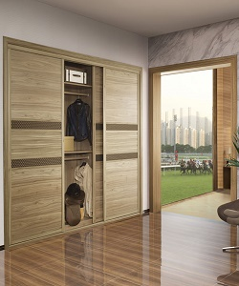

Lexington cupboard

$182.55

Availability: In stock

Description

Modern wooden wardrobe with sliding doors. With its curvaceous contours and spacious glossy surface, glass varnish. The cupboard gives fashionable look to your room.